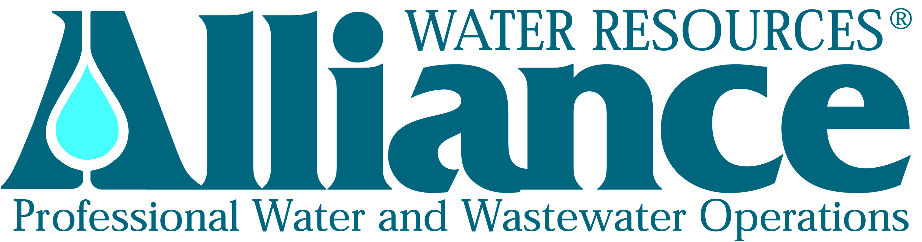
Press Release Contact:
Sandy Neal
FOR IMMEDIATE RELEASE Director of Business Development & Human Resources
Alliance Water Resources
206 South Keene Street
Columbia, MO 65201
Phone: (573) 874-8080

Alliance Water Resources Announces Promotion

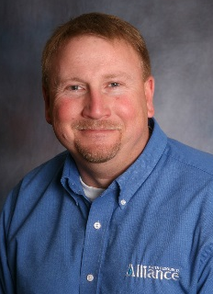
(Columbia, Missouri, October 6, 2014) – Alliance Water Resources, headquartered in Columbia, Mo. and provider of contract operations and comprehensive management services for municipal and community water, wastewater and public works systems in Missouri, Iowa and Tennessee announces the promotion of Mr. Bart Downing. Downing will serve as Division Manager for Alliance operations located in Northwest Missouri including Platte County, Buchanan County, Atchison County, and Holt County.

“Alliance is a great company and a great place to work. I am eager to contribute to and gain knowledge from the finest management team in our industry,” says Bart Downing.

Since joining Alliance in 2002, Downing has been the Local Manager of Alliance’s operations in Platte and Buchanan Counties. Bart has extensive experience in managing, budgeting, planning and business development. He is the current Chairman of the Northwest Section of the Missouri Water and Wastewater Conference and holds operator licenses in Missouri and Kansas.

“Bart is a long term employee with a track record of success. I’m excited to bring his know-how and experience to more of our clients,” says Tim Geraghty, Director of Operations for Alliance Water Resources.

“Downing’s ability to manage multiple locations and proactively resolve issues for the clients he serves has been exemplary. Once again, the company’s strategic planning efforts have made it easy for us to continue our pattern of promoting from within our own ranks. It’s good for our people, and it’s good for our customers. It is very rewarding.” Says Dale Wagner, President of Alliance Water Resources

For more information about Alliance Water Resources, please visit their website at www.alliancewater.com or contact Sandy Neal, Director of Business Development and Human Resources, 206 South Keene Street, Columbia, MO 65201, (573) 874-8080, sneal@alliancewater.com.
###

