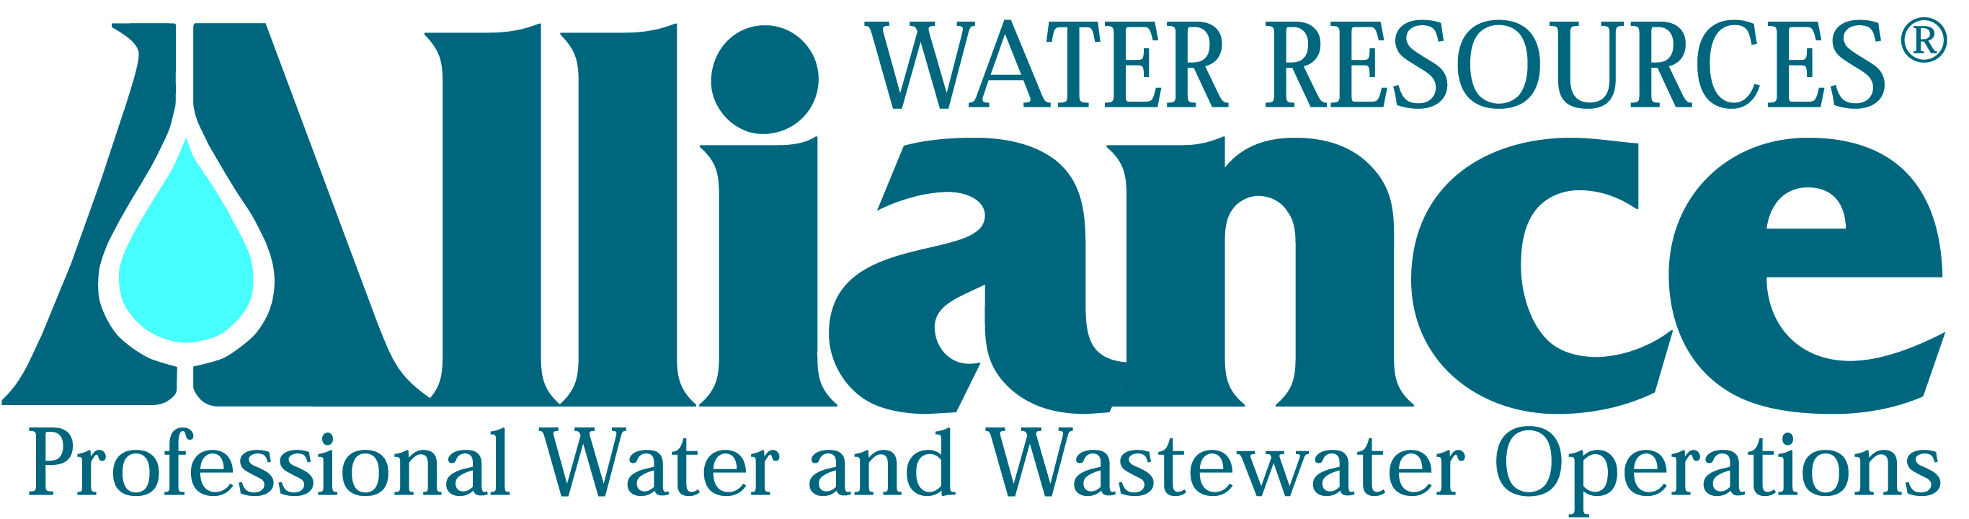
Press Release Contact:
Sandy Neal
FOR IMMEDIATE RELEASE Director of Business Development & Human Resources
Alliance Water Resources
206 South Keene Street
Columbia, MO 65201
Phone: (573) 874-8080

Atchison County Wholesale Water Commission Enters into Agreement with Alliance Water Resources

(Columbia, Missouri, June 20, 2013) – On June 13, 2013 the Atchison County (MO) Wholesale Water Commission (ACWWC) approved a five-year agreement for Alliance Water Resources to operate, maintain and manage the water treatment and distribution facilities for the wholesale customers they currently serve, which includes the cities of Fairfax, Rock Port and Tarkio and the Atchison County PWSD #1.

The ACWWC was formed by joint contract under the Joint Municipal Utility Commission Act set forth in the Revised Statutes of Missouri. Atchison County is located in Northwest Missouri, and the commission consists of the City of Fairfax, the City of Rock Port, the City of Tarkio and the Atchison County PWSD #1. The commission began to find a solution to the water needs in these communities, where current water facilities were old, dilapidated and in need of replacement. Construction on the new infrastructure includes three wells, one 2.5 MGD treatment plant, one 500,000-gallon storage at plant site, one elevated 250,000-gallon tower, 22 miles of transmission lines, metered connections to Fairfax, Rock Port and Tarkio, two high service pumps and one booster pump and began in January of 2012.

Alliance’s responsibilities will include routine inspection, maintenance and emergency repair to all Commission-owned facilities, collection and testing of all water quality samples required by federal and/or state agencies, development and implementation of programs, policies and procedures regarding emergency response and personnel, scheduling of ongoing preventative maintenance, regular flushing, reading meters, preparing monthly bills, responding to utility locate requests, GIS/IT services, recommending system improvements, providing on-call and after-hours response services, and maintaining regular communication with the commission through monthly reports and attending monthly commission meetings.

During final stages of construction, Alliance will provide the operational and management expertise needed to bring the system online. Alliance has significant, qualified experience with start-up operations for water treatment and distribution systems and has assigned Bob Ross as the division manager. Ross’ knowledge and technical expertise will provide the commission with a successful startup slated for September of this year, according to projections from the project engineers and contractors.

Ross first became involved with wholesale water systems in 1982. He served on the steering committee for the Clarence Cannon Wholesale Water Commission and later was on the Board of Directors, a commission that encompassed 12 – 15 counties. Ross was active for many years with the Northwest Wholesale Water Commission, which inspired the development of the ACWWC. He has a long-time interest in these communities and has developed many relationships within the cities and districts in need.

About the benefits that Alliance Water Resources brings to the project, Ross says, “We have experience in wholesale water dealings, both with district and city operations and also with plant and well operations. We bring extensive knowledge and a background of staff that can guide the commission from the onset and well into the future. We also have an aggressive safety program, and because of our all-inclusive fees and buying power, we can provide significant cost savings.”

Once the system is up and running, Ross says their first priority will be to place staff, including a permanent local manager who they hope to have in place by July 15th. Interested applicants can apply on the Alliance Water website at www.alliancewater.com/career-opportunities.

Kyra Mills, Chairman of the Board for ACWWC says, “We felt that given the size of our project it was critical to have someone with a lot of experience in managing a water treatment distribution system. We believe Alliance will bring an economy of scale, professional management and the expertise.” Mills says the number one mission of the project has always been to provide safe, potable water for Atchison and the adjoining communities today and into the future. She believes the project will also allow the Atchison County PWSD #1 the water resources to expand their service to currently underserved water patrons. “We look forward to this relationship with Alliance, and to having them on our side.”

Alliance Water Resources provides contract operations and comprehensive management services for municipal and community water, wastewater and public works systems in Missouri, Iowa and Tennessee. For more information about Alliance Water Resources, please visit their website at www.alliancewater.com or contact Sandy Neal, Director of Business Development and Human Resources, 206 South Keene Street, Columbia, MO 65201, (573) 874-8080, sneal@alliancewater.com.
###

