Press Release Contact:
Sandy Neal
FOR IMMEDIATE RELEASE Director of Business Development & Human Resources
Alliance Water Resources
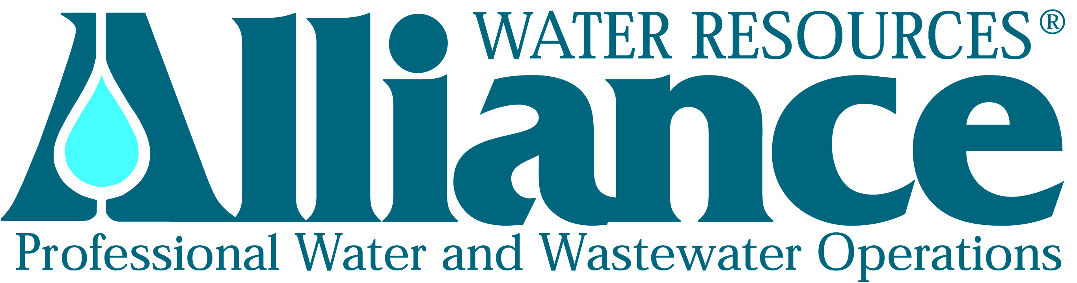
206 South Keene Street
Columbia, MO 65201
Phone: (573) 874-8080

Alliance Water Resources Employee Recognized by Missouri Water and Wastewater Conference

(Columbia, Missouri, October 1, 2014) – The Missouri Water and Wastewater Conference (MWWC) recognized Josh Willison, Wastewater Treatment Operator for Alliance Water Resources at an awards ceremony held September 29 in Jefferson City, Mo.
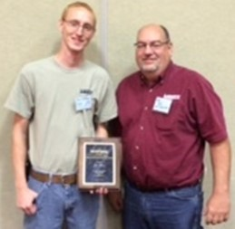
Josh Willison received the Young Professional of the Year Award, which recognizes members with highly developed performance in the fields of water and wastewater operations. It also appreciates those who go the extra mile, working efficiently to complete jobs to the highest of standards. Recipients of this award must be 35 years of age or younger and must be working either full or part time in a field related to water treatment, water distribution or wastewater treatment.
Willison’s experience working with the Missouri Department of Natural Resources prepared him for his current responsibilities operating wastewater treatment plants for Alliance’s Franklin County operations. Alliance Water Resources provides services to over 4,000 customers for Public Water Supply Districts No. 1 and No. 3 of Franklin County, Mo southwest of St. Louis. Willison holds a Class “C” Wastewater Treatment Operator Certification.

“Josh is very proficient, constantly striving to improve our operations to see our facilities have the best performance possible. We are glad Josh is part of our team and appreciate the good work he does for us and our customers,” says Mike Dougherty, Alliance Division Manager.
Pictured: Josh Willison
and Local Manager Bob Hathcock

Alliance Water Resources provides contract operations and comprehensive management services for municipal and community water, wastewater and public works systems in Missouri, Iowa and Tennessee.

“The recognized efforts of Josh Willison represents what our company strives to achieve” says Dale Wagner, President of Alliance Water Resources.

For more information about Alliance Water Resources, please visit their website at www.alliancewater.com or contact Sandy Neal, Director of Business Development and Human Resources, 206 South Keene Street, Columbia, MO 65201, (573) 874-8080, sneal@alliancewater.com.

###

