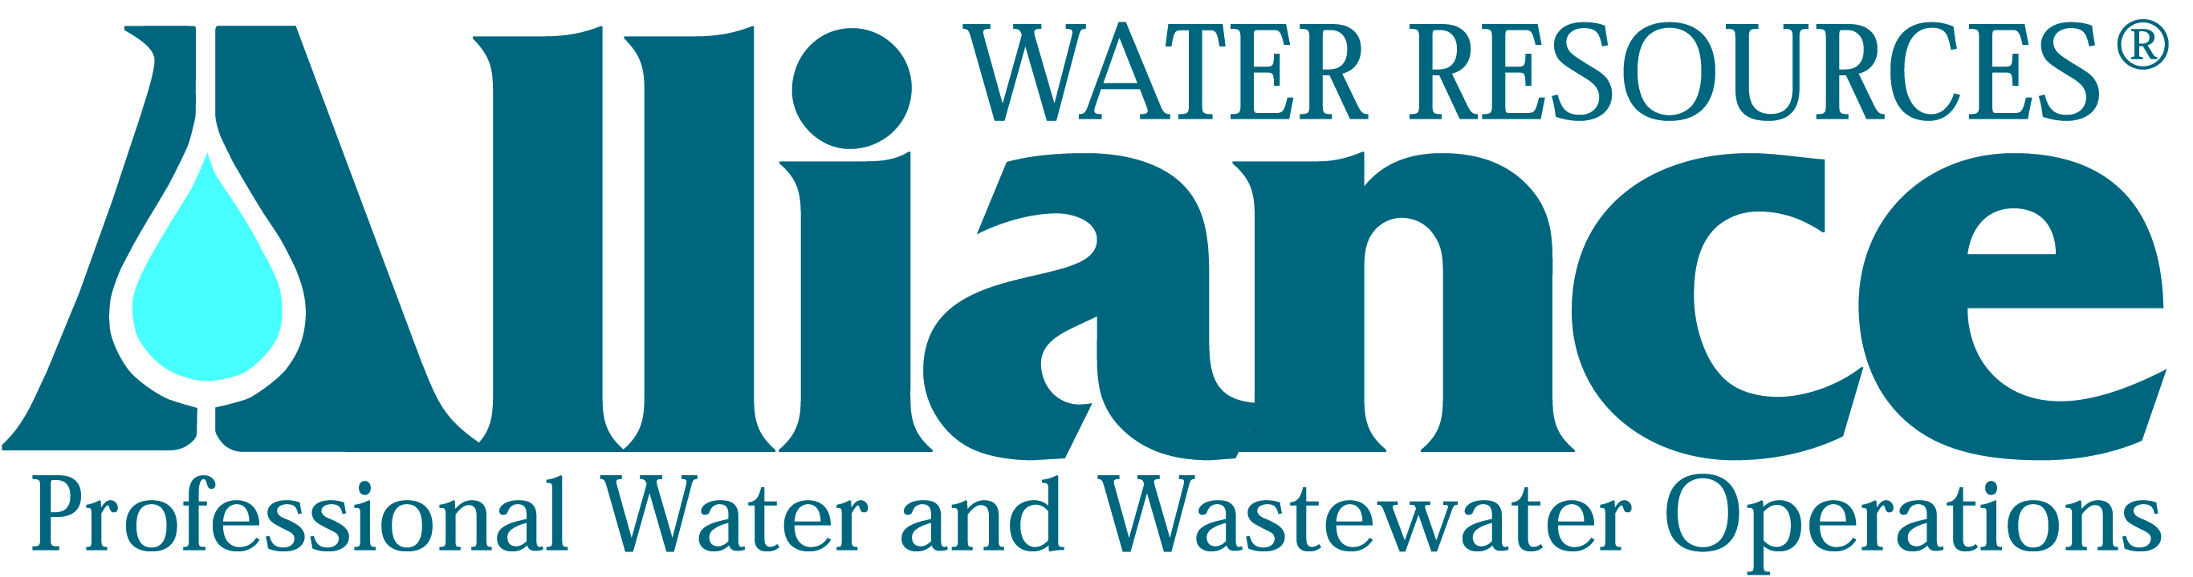
Press Release Contact:
Sandy Neal
FOR IMMEDIATE RELEASE Director of Business Development & Human Resources
Alliance Water Resources
206 South Keene Street
Columbia, MO 65201
Phone: (573) 874-8080

Alliance Water Resources Selects Next Class of Industry Leaders

(Columbia, Missouri, July 11, 2013) – Ten exceptional employees with Alliance Water Resources have been chosen to participate in the Leadership Alliance Class of 2013. Leadership Alliance is a program that was developed by Alliance in 2006 to promote advancement from within. It is modeled after similarly named community and state leadership programs, and identifies employees who have demonstrated exemplary leadership and interpersonal skills.

Of the 17 employees nominated, the top 10 include: Jeffery Lee, Distribution Supervisor of Henry County Water Company; Mark Kelsay, Wastewater Treatment Operator of Cape Girardeau; Lucas Drullinger, Crew Foreman of St. Charles County Public Water Supply District (PWSD) #2; Mike Viessman, Crew Foreman of St. Charles County PWSD #2; Brian Hemmer, Chief Water Plant Operator of St. Charles County PWSD #2; Mike Elliot Jr., Field Maintenance Mechanic of Ralls County PWSD #1; Bob Kerbs, Plant Maintenance Mechanic of Nevada; Fred Max Frakes, Operation & Maintenance Mechanic of Nevada; Lonnie Madole, Operation & Maintenance Mechanic of Franklin County PWSD #3; Joseph Swhweiss, Field Maintenance Mechanic of Ste. Genevieve.

This active program strives to connect employees’ technical proficiency with the increasing need for governmental, professional and communications expertise. Participants will complete a total of two, two-day intensive training sessions on industry topics. Instruction on public project funding, workforce planning, governmental processes and other system management comprehension are included in the program. In addition, participants complete self-study homework assignments and are required to give a presentation to the group.

Alliance encourages personal and professional development for all its employees. “We value our employees and strive to develop a company culture that is positive, supportive and challenging,” says President Dale Wagner. “We want the client communities we serve to see quality and value throughout the company. We want them to see problem solvers and leaders in everyone who works for Alliance. And, we want them to see our passion for our jobs and the resulting good service. The best way for Alliance to do this is to encourage leadership at all levels in the company. This program provides tools and resources that helps employees identify steps they can take to advance their career in the direction that will meet their personal goals as well as serve the company and its customers.”

Classes for the 2013 Leadership Alliance program will be held in Columbia, Mo. on October 3-4 and again on November 7-8.

Sandy Neal, Director of Business Development & Human Resources says, “District and municipal leaders depend on us to recruit and retain qualified, licensed operators for their local systems. Leadership Alliance helps us prepare already talented employees to become the next generation of system managers.”

The Alliance organization is made up of more than 250 professional, technical and administrative employees including registered professional engineers, chemical engineers, sanitary engineers, biologists, microbiologists, chemists, accounting and finance professionals, computer programmers, certified water and wastewater operators, laboratory technicians, and electrical and mechanical technicians.

“After completing the Leadership Alliance program, our employees will have a more in-depth understanding of how the company as a whole operates, what leaders in the company actually do, and what it took for those leaders to achieve their current positions,” says Wagner. “In addition, these exceptional employees will have developed new relationships, not only with the current leaders in the company, but with future leaders just like themselves from across our entire company.”

Alliance Water Resources provides contract operations and comprehensive management services for municipal and community water, wastewater and public works systems in Missouri, Iowa and Tennessee. For more information about Alliance Water Resources, please visit their website at www.alliancewater.com or contact Sandy Neal, Director of Business Development and Human Resources, 206 South Keene Street, Columbia, MO 65201, (573) 874-8080, sneal@alliancewater.com.
###

